***CIS623 Project 1***

**Retirement Planning Calculator Submitted By Lohith Nimmala**

Entire UI is available at : <https://lohith499.github.io/cis623>

Entire Code for this is available at : <https://github.com/Lohith499/Ballpark_Retirement_Calculator>

While filling out Forms which require lot of fields would make the user to panic if all those questions and required field are displayed at a time.

Instead if we can only show limited information at a time that would let user to understand that part easily and can move forward without doing any major mistakes.

Based on that point I made my design in sections which are displayed one after the other so user can understand what all details he/she need to produce and how they are being calculated

Also the Info tips instead in each section has been provided by default instead of hiding then and display on clicking some button since user may not be aware of such tips and how they can be useful if we hide them.

UI Home Page

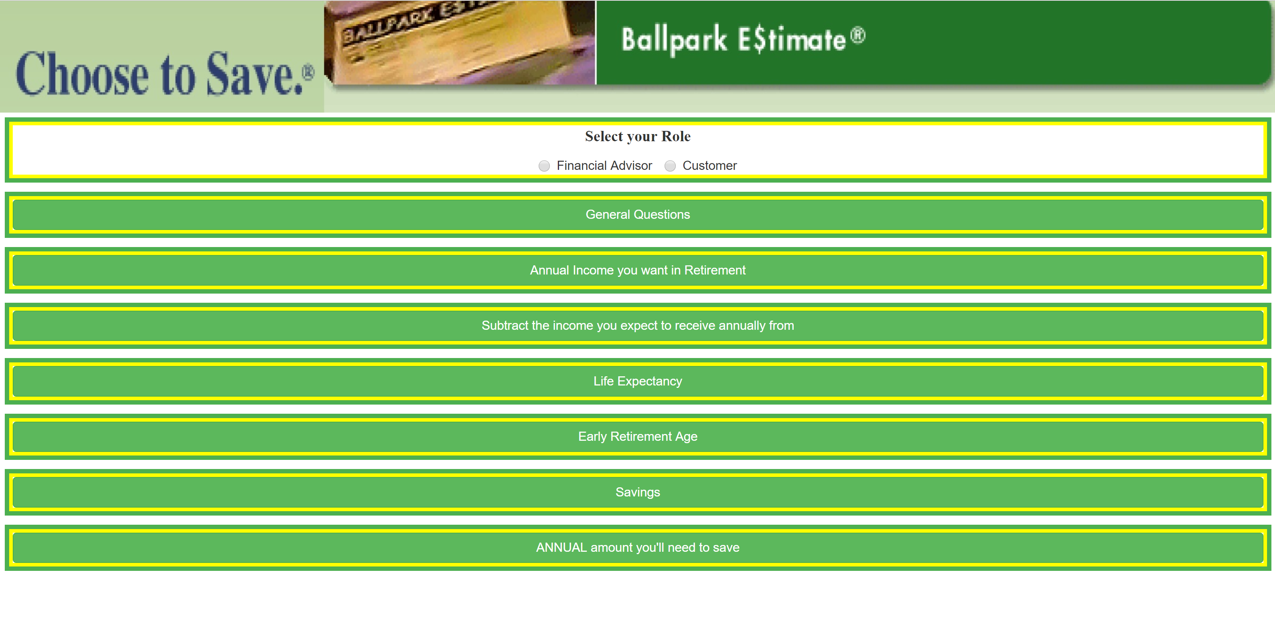

User can select this App as a Customer or Financial Advisor

When user selects as Customer their next action would be as shown below

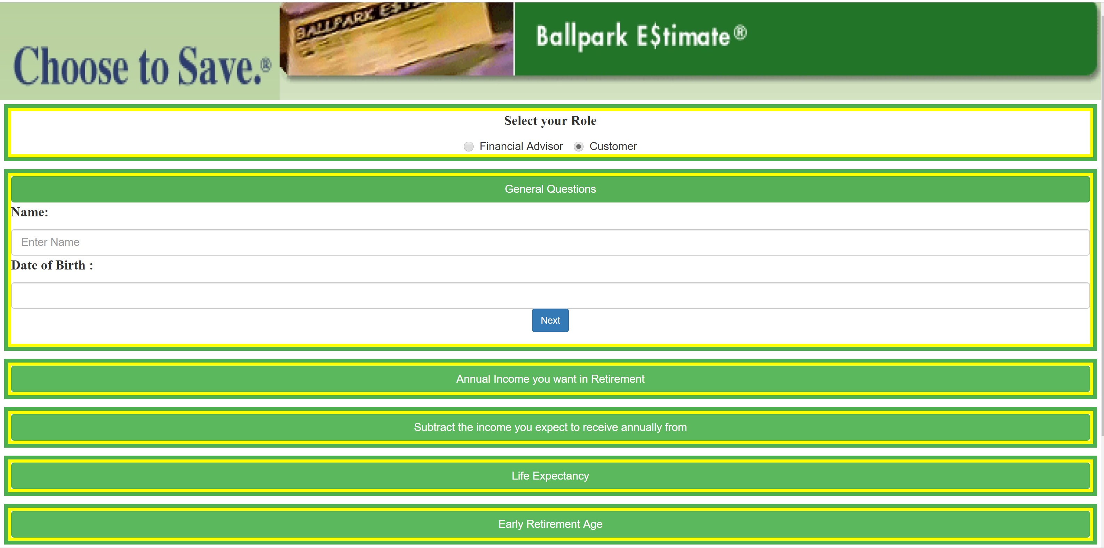

If User select his role as Financial Advisor(Don’t need to fill general questions) their next action would be

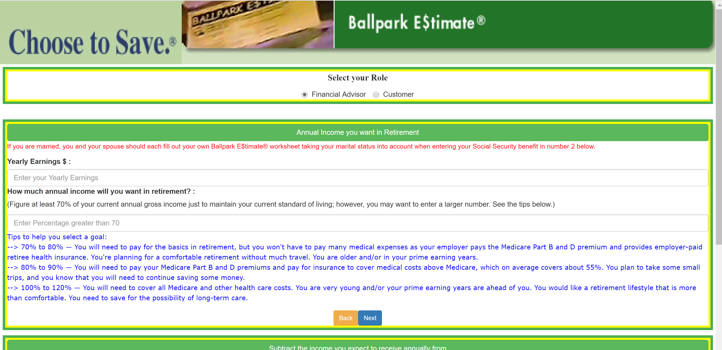

Each Section is provided with Back and Next Button , by filling out the forms with all Information and on Clicking next it would automatically hide the current section and display the next section

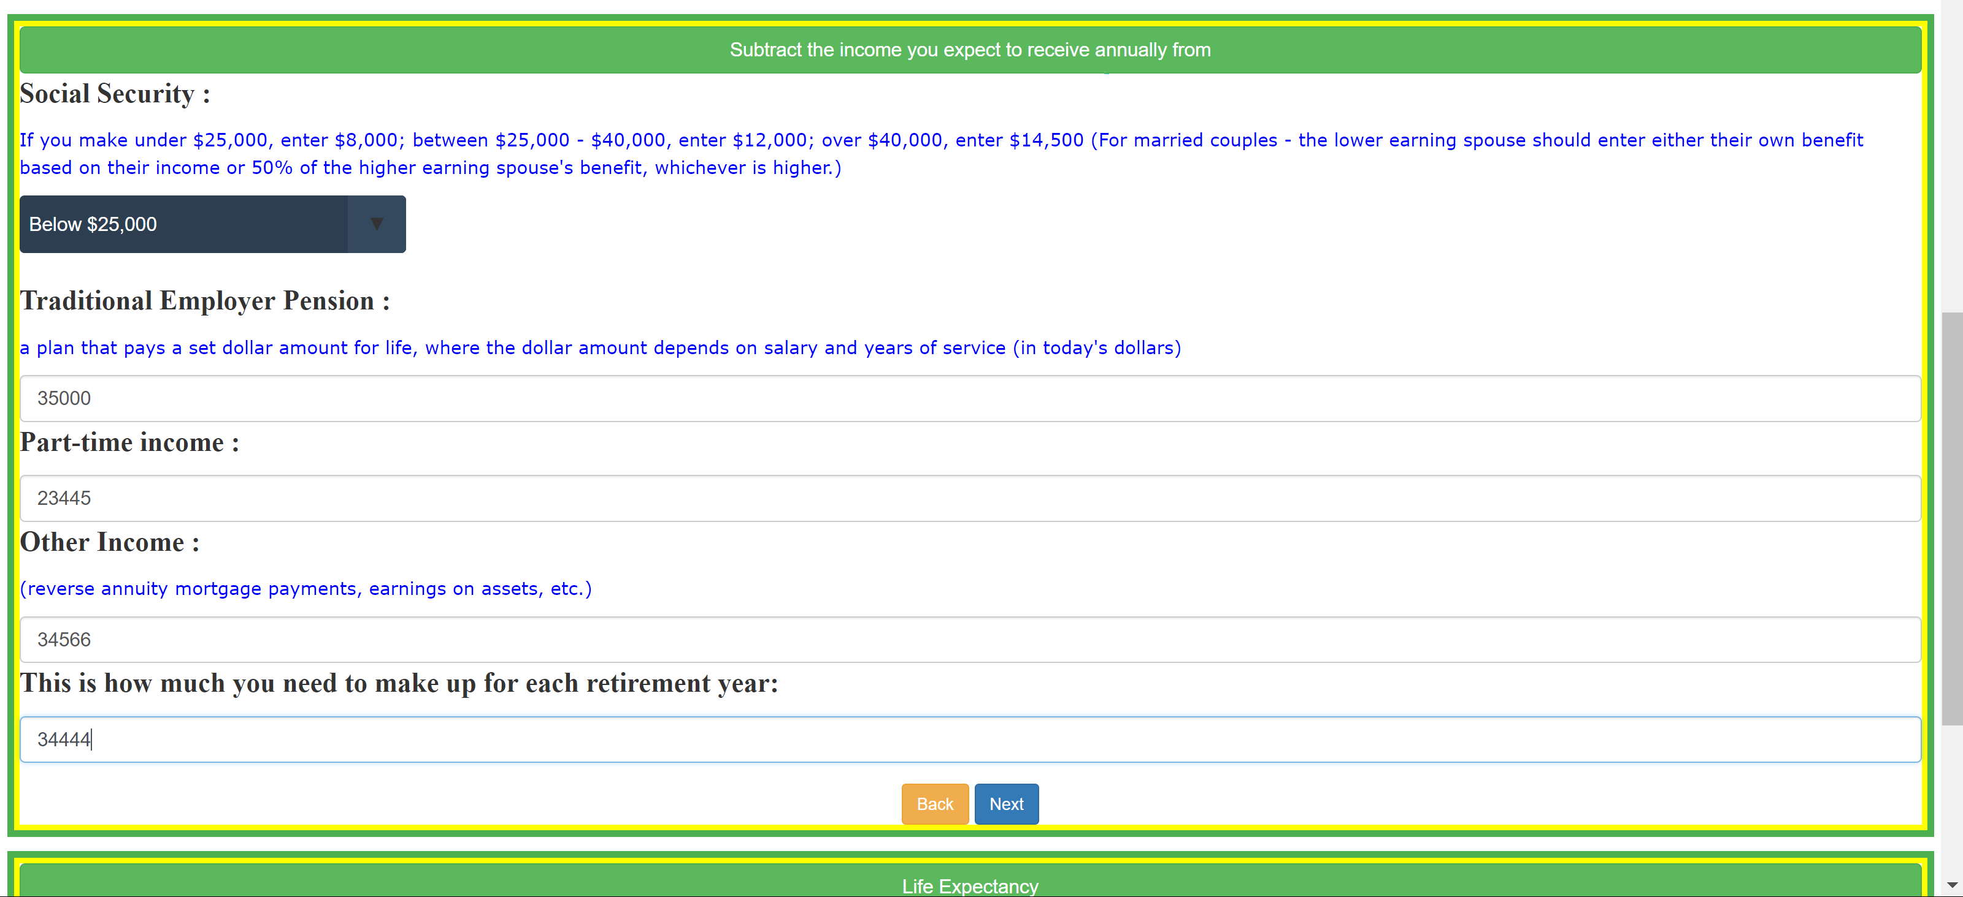

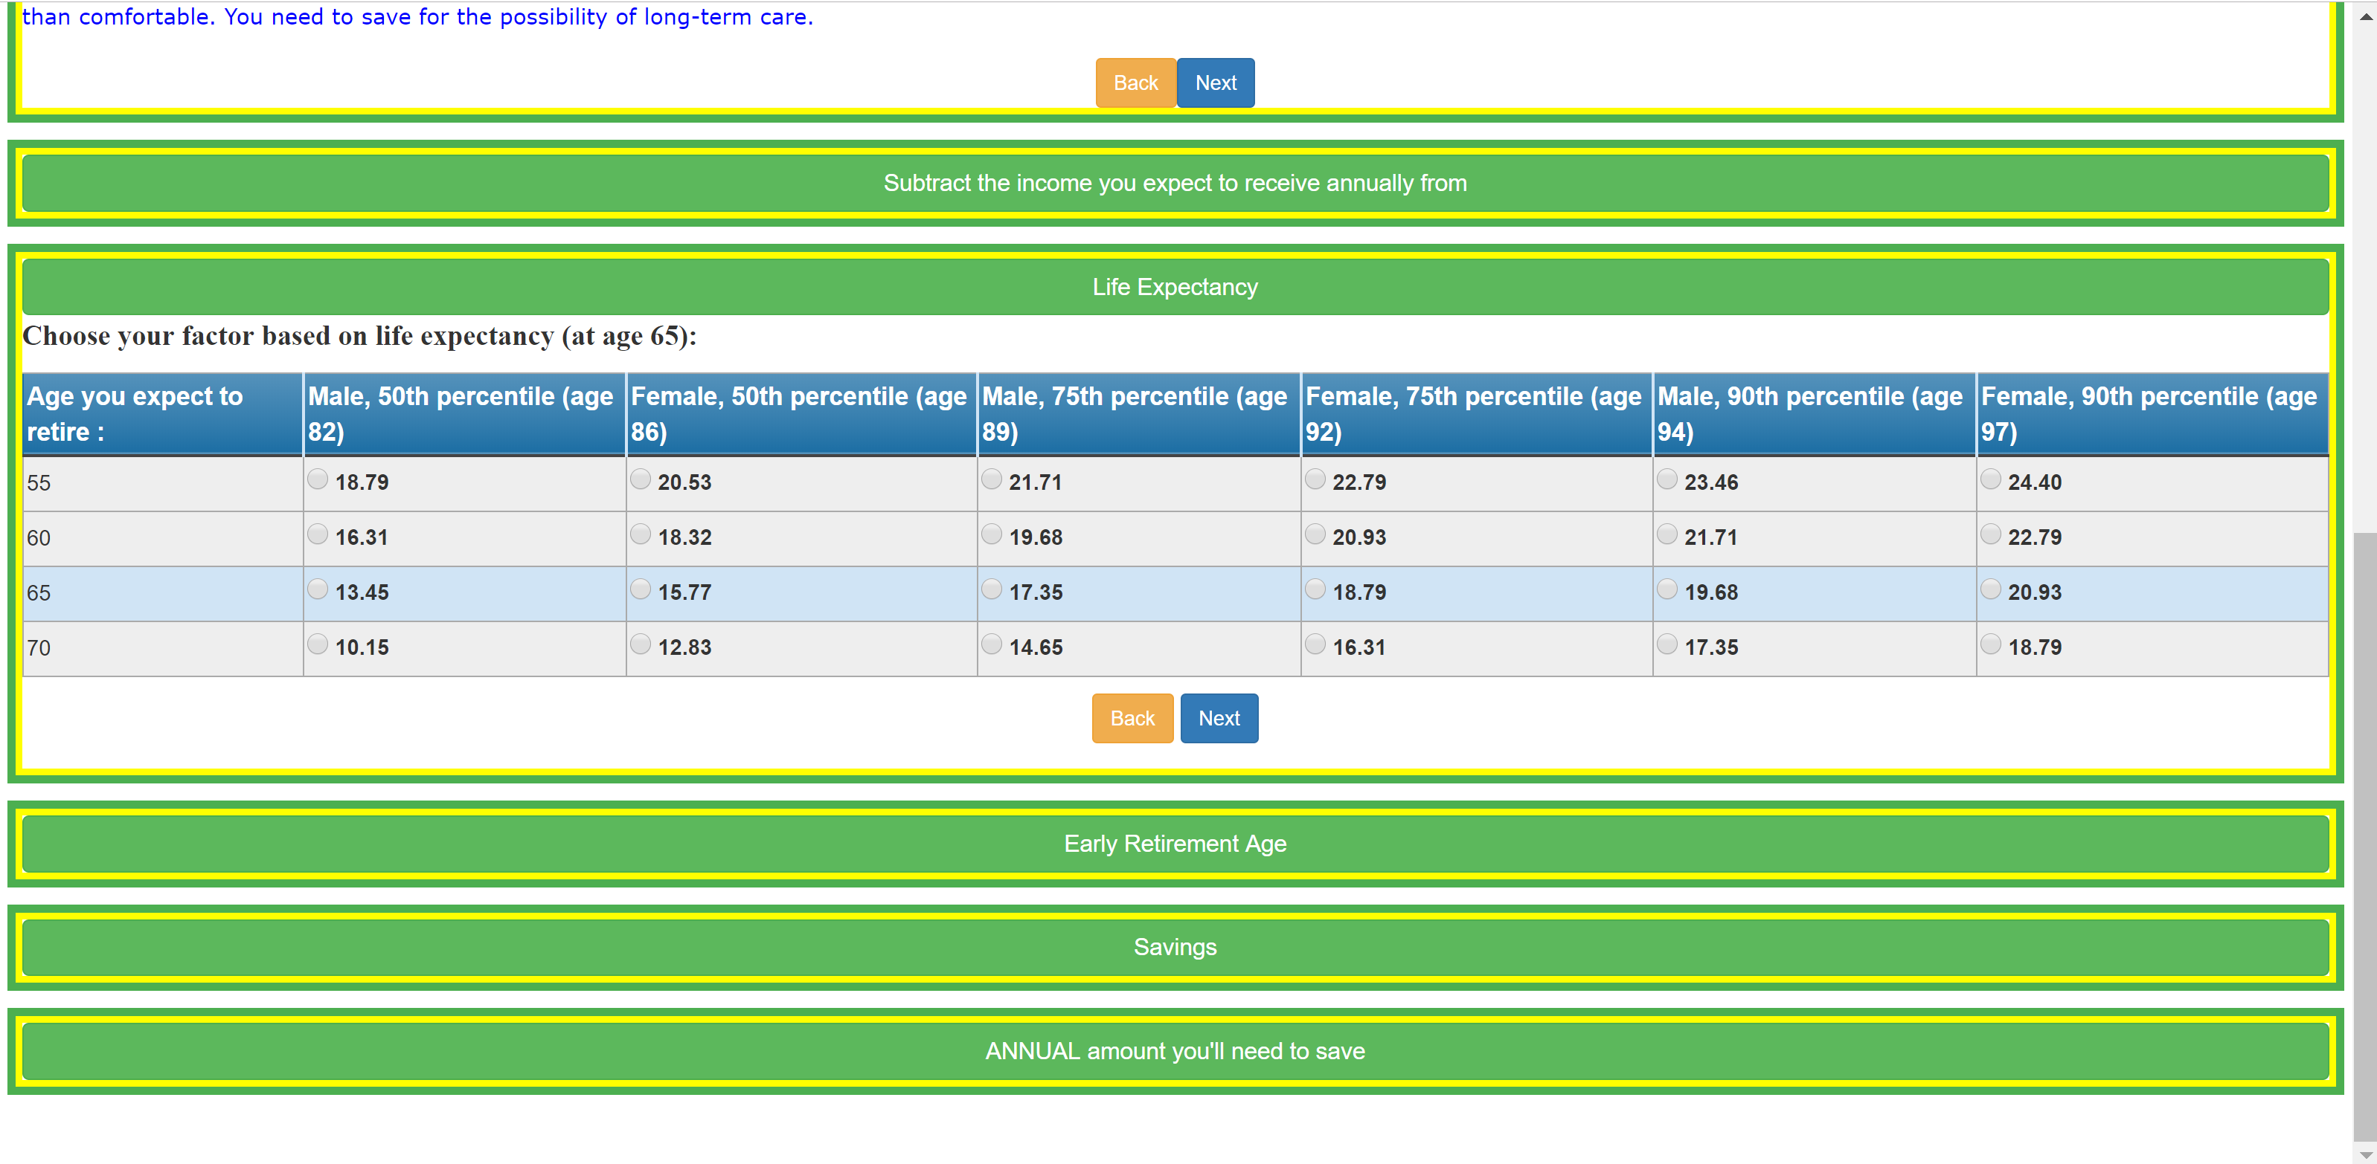

User can go back see the info they have submitted by clicking back button

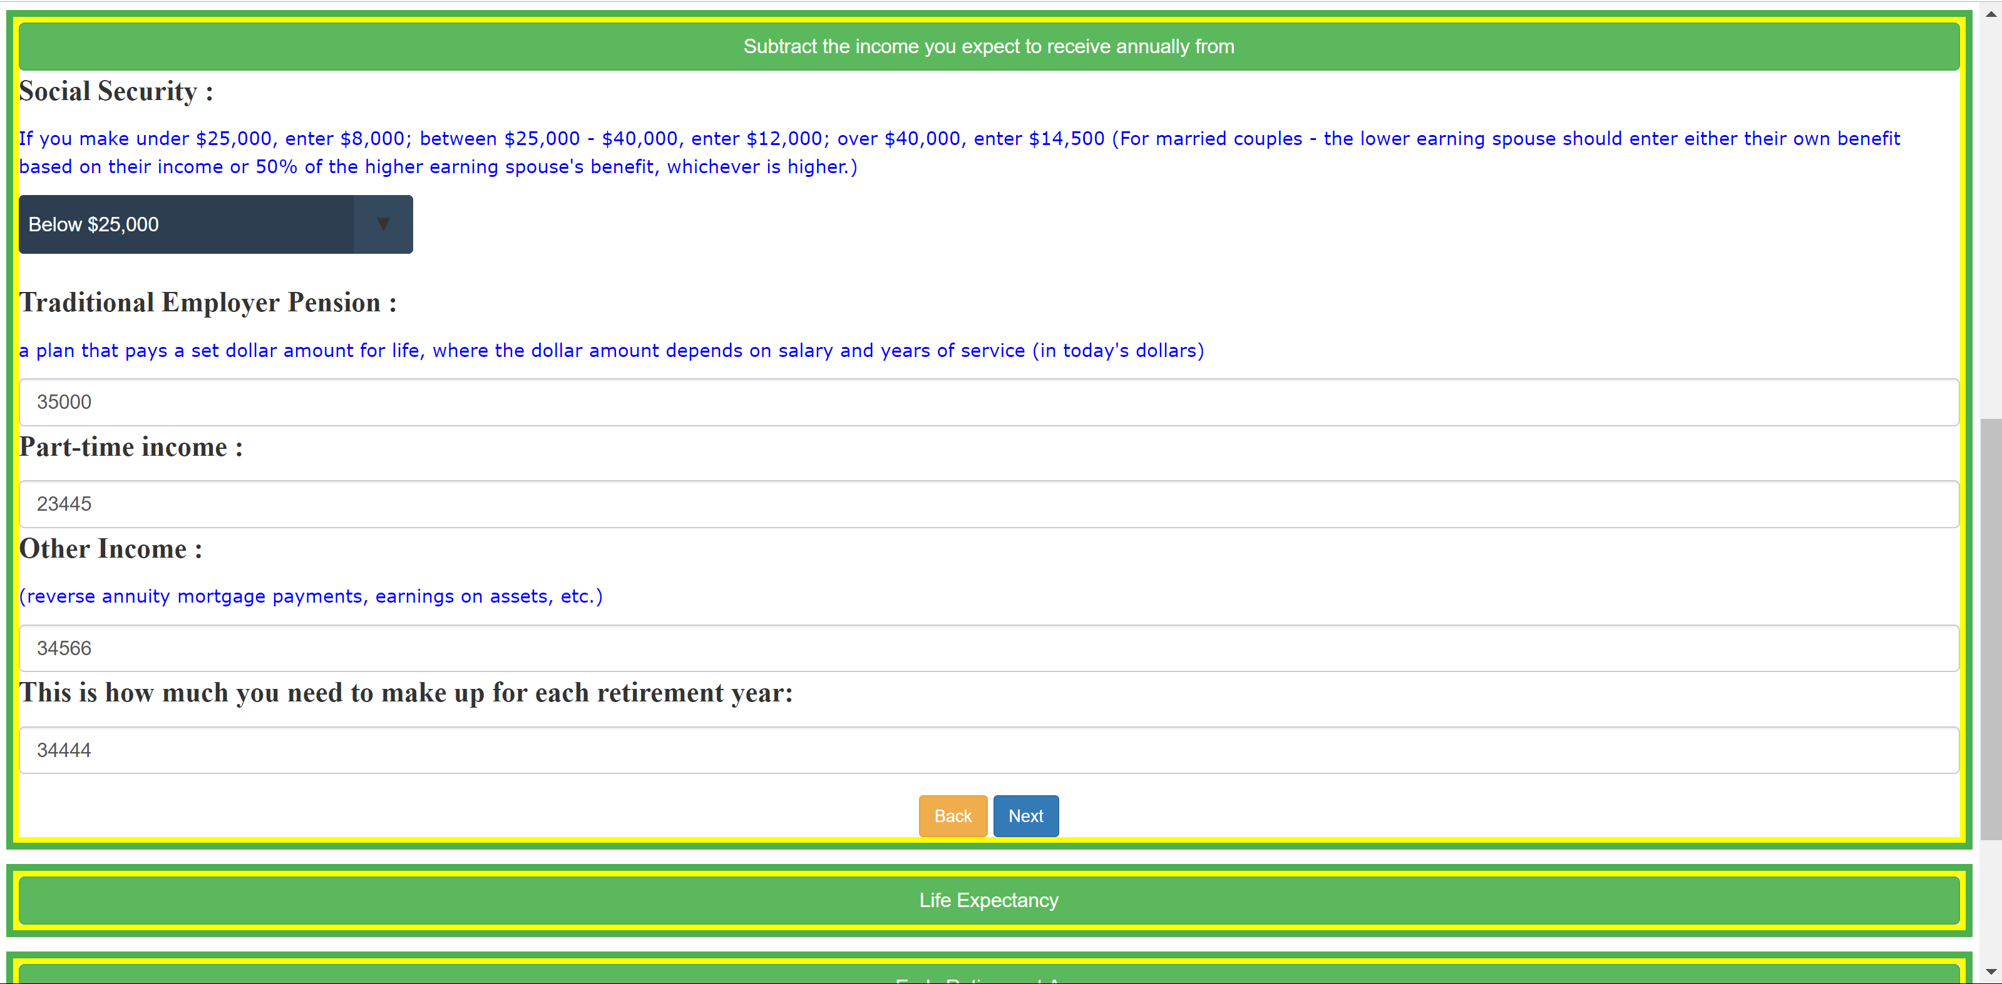

At any moment if user want to see all the section , simply by clicking on the Headers of section would open up and display the content

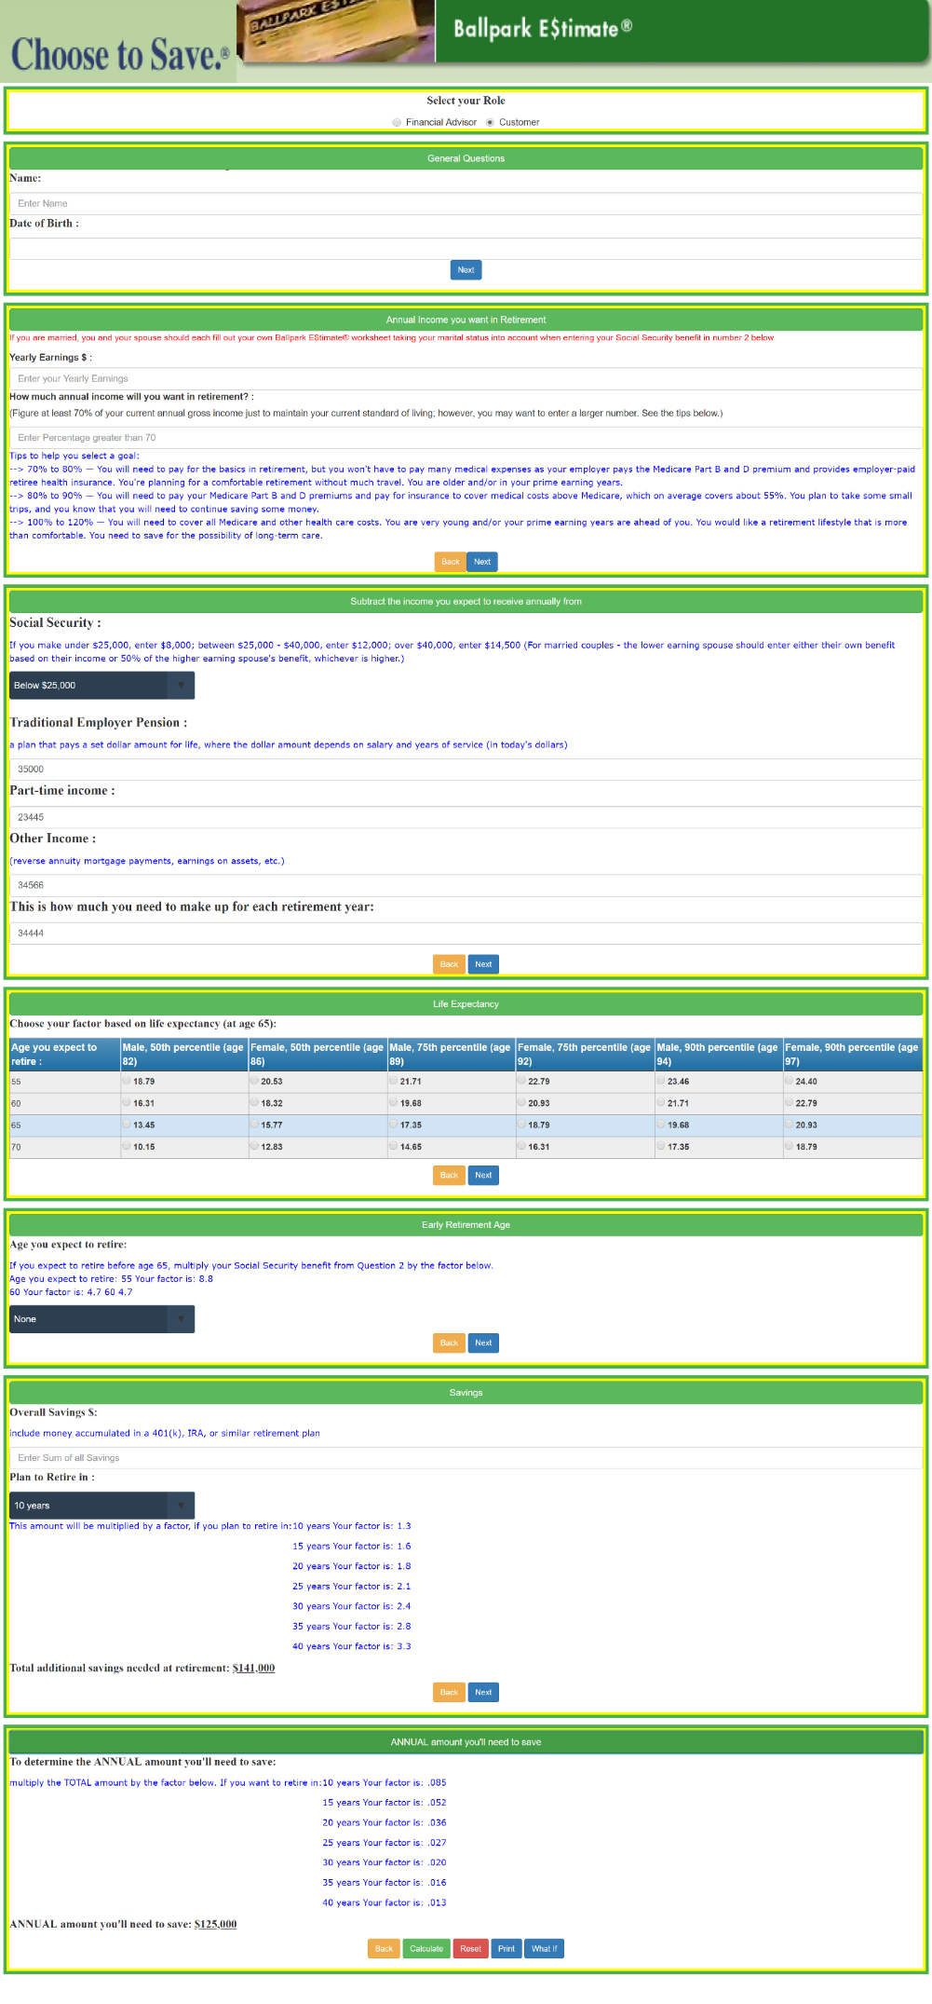

Calculate button at the End of the Page would Calculate the Sum and Reset button will Clear all the Values

On Clicking the Print button user can view all the Info submitted and can get it printed .

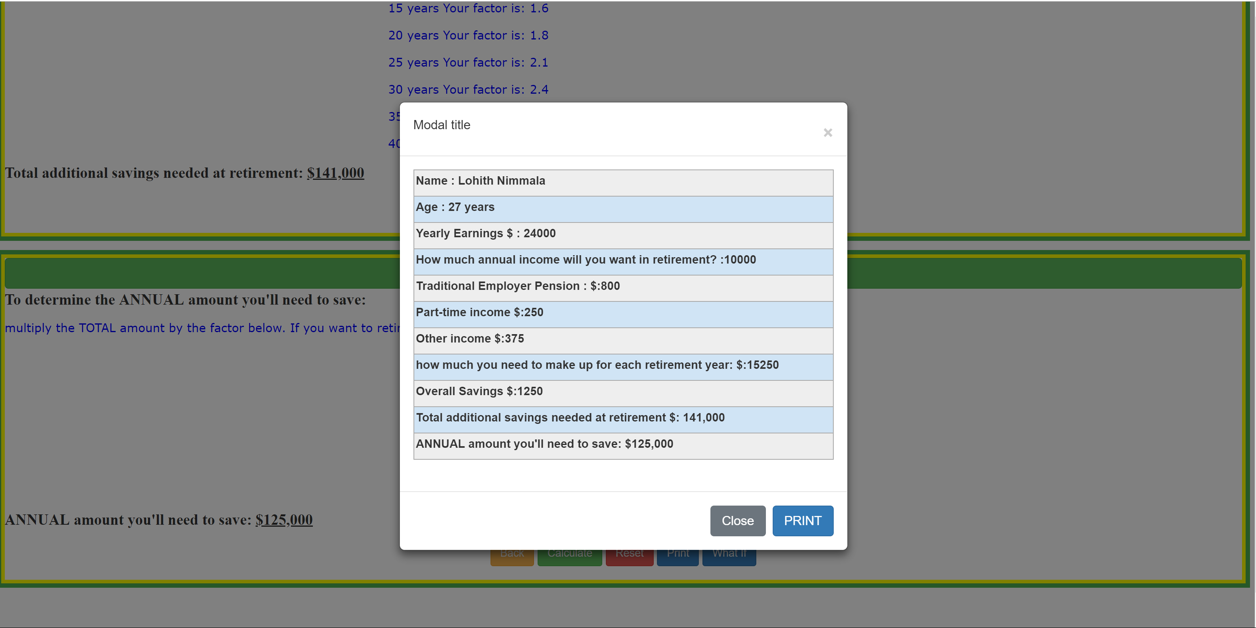

On Clicking What If button in last section can view limited fields and update their values

